Alan Yu

Organic Lab 309:03

Santanu Malakar

Experiment 18: Structures and Properties of Stereoisomers

April 22, 2019

**Purpose:**

To see the stereoisomers and optical rotations for compounds in the experiment.

**Equations:** (from lecture notes)

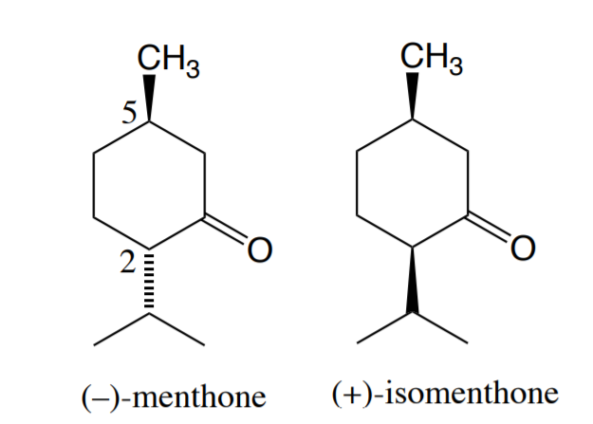

**Mechanisms:** (from lecture notes)

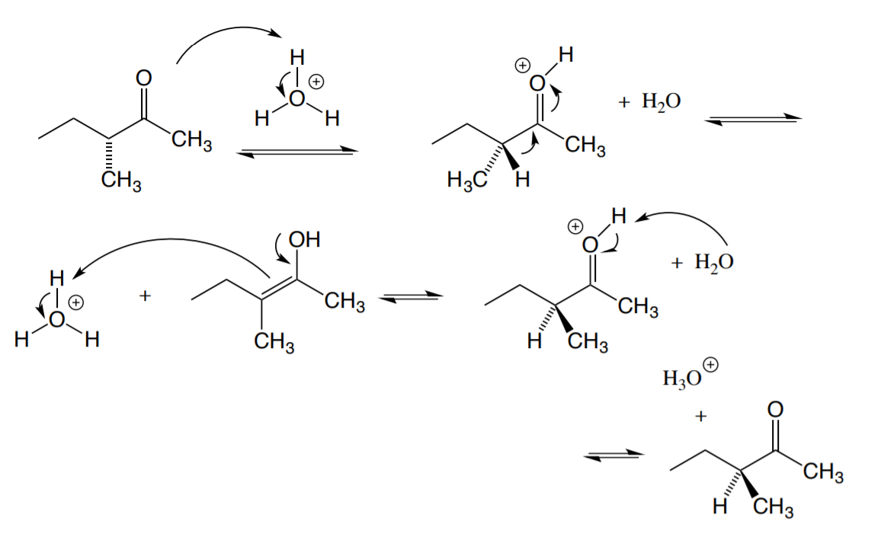

**Amounts and Properties:**

Table 1: Important properties and amounts

| **Chemicals** | **Mol Wt** | **D** | **[∝]** | **Amount** |
| --- | --- | --- | --- | --- |
| (R) - Carvone | 150.2 | .96 | -62° | 1 mL |
| (S) - Carvone | 150.2 | .96 | +62° | 1 mL |
| (-) - Menthone | 154.2 | .895 | -30° | 1 mL |
| (+) - Isomenthone | 154.2 | .9 | +92° |  |
| Acetic Acid |  |  |  | 5 mL |
| 1M HCl |  |  |  | 5 mL |

**Hazards and Safety:**

Acetic Acid causes chemical burns that can seriously damage skin and eyes; its vapors are highly irritating to eyes and respiratory tract. Wear globes and dispense under a hood; avoid contact and do not breathe its vapors. Diethyl ether is extremely flammable and may be harmful if inhaled. Don't breathe its vapors; keep away from flames and hot surfaces. Do not breathe HCl vapors and avoid contact. Dispose all chemicals under the hood in labeled containers.

**Procedure:**

**Isomerization of (-) - Menthone:**

The purpose of adding acid compounds with (-) - methone is to induce the isomerization of the compound. Having acids isomerizes the (-) - methone into (+) - isomenthone counterparts. After isomerizing, adding the base induces some of the isomenthone that was created back into the menthone counterparts to test the optical rotation of each compound.

**Properties of Carvone from Spearmint and Caraway Oils:**

Measuring the boiling point of each carvone should show that each carvone has the same boiling point, but for the refraction index, it should show different values. IR can also help distinguish what kind of carvone, S or R, it is. Testing the rotation also helps distinguish which compound is which.

**Observations:**

After completing the reflux, one portion of the NaOH that was added was contaminated which turn the solution yellow. While rotovapping there was a solid that was created as well as a small amount of liquid that was created that was light yellowish in color. For the Carvone samples, Carvone B smelled like poppy seeds while Carvone A smelled like wintergreen.

**Measurements:**

Table 2: Methone and Blank (made using 10mL of Ethanol)

| Blank c value: 163.13 | Sample c value: 163.28 |
| --- | --- |
| 250 mL flask: 111.193g | After mass: 111.662g |

Table 3: Carvone and Blank (made using 10mL of Ethanol)

| 95% Ethanol Blank | 153.09 |
| --- | --- |
| Carvone B | 178.70 |
| Carvone A | 126.89 |

**Data and Calculations:**

Specific rotation = observed rotation / (1 decimeter * # of grams solute per mL of solution)

**Part A:**

111.662g - 111.193g = .469g solute created

.469g / 10 = .0469g / mL

163.28 - 163.13 = 0.15 → .15 / .0469 = 3.1983°

92 - 3.1983 = (88.8017 / 122) * 100 = 72.79% methone

100 - 72.79 = 27.21% isomenthone

**Part B: Assuming 1g / 10 mL**

Carvone A:

126.89 - 153.09 = -26.2 / .1 = -262° rotation

Carvone B:

178.70 - 153.09 = 25.61 / .1 = 256.1° rotation

**Discussions:**

For part A, the lower yield could be from the reflux not going to completion or from the rotovapping where solid was left by the neck of the round bottom flask. The mixture came out to have a 72.79% menthone to a 27.21% isomenthone ratio. This shows that the menthone compound was better to exist than that of isomenthone. This is due to the methane group on isomenthone to be in the axial position which can have interactions that are worse than the equatorial position of the methane in the methone. For Part B, the Carvone A had a -262° rotation compared to Carvone B which had a 256.1° rotation. With that, Carvone A can be concluded to be the (R)-Carvone while Carvone B could be concluded to be (S)-Carvone. Although these rotations are too different from the documented values of ±62°, they are almost equal and opposite which demonstrate the properties of structural isomers. An error from this experiment could’ve been that the rotations were too fast for the machine that was reading it, which can cause false readings.

**Conclusions:**

From this experiment, the menthone and isomenthone solution that was prepared had a 72.79% menthone to a 27.21% isomenthone ratio which shows that the menthone was predominant naturally. For Part B of the experiment, although the rotations were off the charts, they still remained almost equal and opposite representing the property of structural isomers.

**Exercises:**

1. The enantiomers for the Carvones had specific scents that were tied to each other. Carvone A had a poppy seed smell while Carvone B has a wintergreen smell. Since these two carvones are the same product, their IR should not differ much or in any way.
2. A.

Since there are more substituents on the equatorial axis on the first structure, the first structure is way more stable than the second structure.

B. This lines up with the conclusions since there was a 72.79% menthone to a 27.21% isomenthone ratio.

5.

Since the carbon group to the right of the ketone is the only one undergoing a change, and since there are two stereocenters, only one change creates a diastereomer. This creates the (+)-isomenthone instead of (+)-menthone.

6.

Since there are three different stereoisomers the mixture that is created could be a racemic mixture which allows for the difference in melting points. For the 0 degrees rotation, it is because the two isomers are mirror images of each other and the meso compound is symmetrical vertically, the chance of being a 0 degree rotation is really high.

7.



Each dot is a stereocenter along with the drawing. Since the equation for number of stereoisomers is 2 to the power of n, where n is the amount of stereocenters. Since there are 11 stereocenters, 2 to the power of 11 is 2048.